INSTRUCTIONS FOR PREPARING AWPT2021 PROCEEDINGS

Taro Fujiyama^{*1}, Sakura Haruno^{*2}, and Koyo Akino^{*1}
^{*1} CMP University, xxxx, xxxx, Kanazawa, Ishikawa 920-xxxx, Japan, xxx@xxxx.xxx.xx
^{*2} Planarization Co. Ltd., xxxx, Suita, Osaka 565-xxxx, Japan, xxxx@xxxx.xx.xx

Keywords: Chemical mechanical polishing/ planarization, AWPT, Online workshop, Template, Zoom system

1. Introduction
The standard number of pages for extended abstracts is two pages of text and the extended abstract should be include supporting figures. The extended abstract title should be 14-point bold Times font and centered on the page.
The author’s name(s) should be listed in 10.5-point Times font, centered on the page. Author affiliation and e-mail address information should be in 10.5-point Times font, centered on the page, just below the names.
The three to six keywords also should be listed in in 10.5-point Times font.

2. Contents
All other text should be 10.5-point Times font in double column format. Paragraphs should be single spaced and fully justified. Leave a blank line between paragraphs, such as shown in this template. When citing a reference in the text, type the corresponding reference number in square brackets as shown at the end of this sentence [1].

3. Figures and Tables
Figures should be referenced within the text as “Fig. 1.” However, please use “Figure 1” instead of the abbreviation, when the reference to a figure begins a sentence. Please ensure that all the text in your figures is large enough to be clearly read. Since the proceedings is distributed as only an electric version, full color figures are available. Concerning a table, please place the table number and title above the table, as shown in Table 1.

Fig.1. A caption for a figure.

4. File format
Submissions should be sent in one of two formats, Adobe Acrobat PDF (strongly preferred because it significantly reduces the file size) or Microsoft Word.
Abstracts should be formatted for A4 paper (210 mm x 297 mm) leaving a 20 mm margin on top, bottom and both sides. The corresponding author’s name, phone number, email address, affiliation, and contact address should be listed as a footnote.

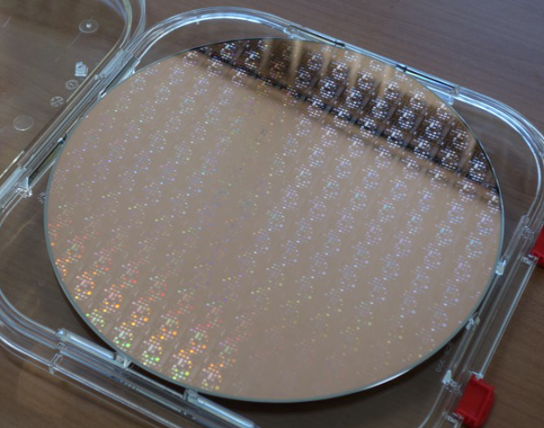
Fig.2. A caption for a figure.

Table 1. A caption for a table.
Sample # | 1 | 2 | 3
Removal rate [nm/h] | xxx | xxx | xxx
Roughness [nm] | xxx | xxx | xxx

5. Conclusions
The extended abstracts must be submitted by the end of day, September 17, 2021. Please submit your abstract by email to awpt2021@gmail.com.

References
[1] X. Xxxxx, Y. Yyyyy, et.al, Title xxxx xx xxxx xxxx, Journal of xxxx, 10 (2020) 111.

